***Lane Transit District Board***

***Strategic Planning Work Session***

November 12, 2014

**Briefing on Strategic Themes for 2015-2025**

**Overview**

*"No battle plan ever survives first contact with the enemy."* [1]

This saying, attributed to a German Field Marshall in the late 1800’s, originated as a sort of 'Murphy's Law' of military combat. In the same vein, Napoleon was attributed to have said "I have never had a plan of operations."

This is an understandable sentiment, given the high degree of uncertainty that surrounds military combat. One has only to think of France’s Maginot Line - the vast fortification that spread along the French/German border put up to defend France during World War II. The strategy was completely undone by Germany’s strategy of “lightning war” or blitzkrieg.

Many parallels might be drawn between the “fog of war” and the “fog of the future”, but what we know under either case is limited - entirely provisional until the moment we engage a fellow combatant or the future. Instead of a “battle plan”, we need to have an approach that enables us to consider multiple perspectives and strategic options - maintaining a nimbleness that allows us to adapt to future opportunities and threats.

How to proceed? Harvard Business School researchers Anthony Mayo and Nitin Nohria note in their recent book *In Their Time [2]* that a defining characteristic of the greatest leaders in the twentieth century was a quality they termed “contextual intelligence”– the “profound sensitivity to macro-level contextual factors in the creation, growth, or transformation of businesses.” They describe this as a “sensing capability” or an understanding of “how to make sense of one’s time and to seize the opportunities it presents.”

Developing this ability to assess uncertainty systematically, sense opportunities, and avoid threats is at the heart of the successful strategy.

This briefing document is intended to provide an overview of some of the key contextual factors facing LTD over the next 10 years.

**Framing LTD’s Strategic Issues**

The ancient Greeks believed that Delphi was the center of the world and in the oracle was foretold the future of kings and common men.

If we could ask the Oracle at Delphi about upcoming opportunities and threats facing LTD, how would we frame the question?

To help focus our efforts, it is important to start with articulating our aspirations - what we are trying to accomplish - why we do what we do. This is articulated in the draft LTD Road Map as, “*We provide people the independence to achieve their goals, creating a more vibrant, sustainable and equitable community*.”

With this in mind, we might frame a focal question as follows:

“How might service costs, funding levels, public policy-making, and community support play out over the next 10 years in ways that affect LTD’s ability to provide its services to meet community needs (provide people the independence to achieve their goals, creating a more vibrant, sustainable and equitable community)?”

The underlined items in this question represent the broader strategic factors affecting LTD’s future. For each of those factors, there are a number of driving forces that will influence our decision-making in the coming years. For example, our service costs are affected by (though not limited to):

* fuel price volatility,
* labor costs,
* healthcare costs,
* future skill set requirements, and
* technology

The next sections will provide more detail on the trends and status of driving forces affecting future choices and decisions LTD may be making.

* Fuel Price Volatility,

**Service Costs**

* Technology
* Future Skill Requirements
* Labor Costs
* Healthcare Costs

**Fuel Price Volatility**

In a typical year, LTD will purchase around 1 million gallons of fuel. While our investment in hybrid technology is helping to manage the increase in that amount, hybrid conversion is a longer-term strategy. It doesn’t address the issue of fuel price volatility. A fuel price increase of $.50 can have a significant budget impact.

The most volatile element of LTD’s operational costs is associated with fuel. LTD will face rising and uncertain energy costs due to fuel price volatility and emerging propulsion technologies. The Long-Range Financial Plan assumes that average fuel expenditures per gallon will be $3.75 through FY 2014-15. Fuel price inflation will be 5 percent per year after that compared to the 4.5 percent increase associated with overall costs.

**Driving Forces**

**Technology Advancements**

Overall costs are expected to rise on average 4.5 percent annually (LTD’s FY 2014-15 Long-Range Financial Plan). Growing our services will require effective management of key cost areas (fuel, labor, health care, pensions).

The complexity of propulsion technologies will continue to evolve from where they are today. While technology trends are uncertain, systems will likely become more complex and efficient—influencing both the skill sets required to maintain new technologies and the costs of operations.

In the long run, hybrid technology will save us fuel costs. At the point where all-electric propulsion becomes feasible for transit fleets, fuel costs (net of electricity costs) can be employed in service increases and other expenses.

**Future Skill Requirements**

As the complexity of fleet technologies evolve over time—so must the capacity of LTD's workforce. Personnel must have advanced skills that not only enable them to work on cutting-edge systems, but also have the capability to be adaptive and creative in ways that can facilitate the absorption of innovative, new strategies.

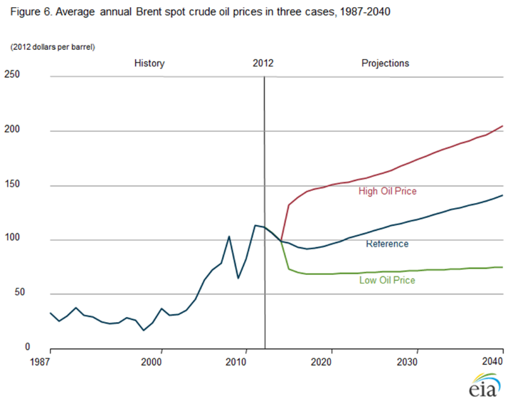As noted by the Institute for the Future, “To be successful in the next decade, individuals will need to demonstrate foresight in navigating a rapidly shifting landscape of organizational forms and skill requirements.

**Chart 1**

They will increasingly be called upon to continually reassess the skills they need, and quickly put together the right resources to develop and update these. Workers in the future will need to be adaptable lifelong learners.”[3]

**Labor Costs**

Like other transit operations, personnel wages and health care costs are a significant proportion of LTD’s operating costs. Personnel costs will likely reflect an increasing and uncertain trend. Changing 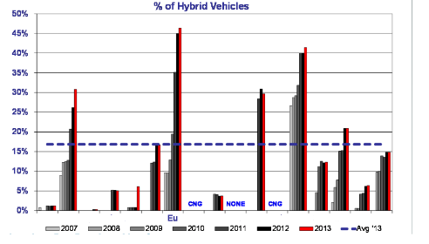demographics, new generations with different values entering the labor force, new technologies, and the demand for a creative and adaptive workforce will create challenges for LTD and its partners in the years ahead.

**Chart 2**

**Healthcare Costs**

Health insurance premiums increased by 9.9 percent from 2013 to 2014. Since that contract is on a calendar year, the rate hold is locked in for the first six months of FY 2014-15. From January 1, 2015, through June 30, 2015, the increase is assumed to be 10 percent. Terms of coverage will remain the same.

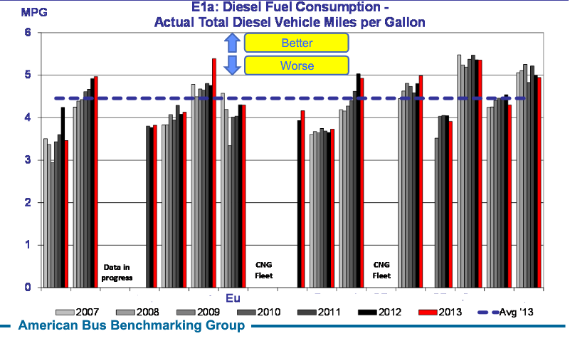

Chart 2 shows the increase in the Hybrid proportion of our fleet (currently over 45%) relative to other ABBG participants since 2007. Note that we have the highest hybrid percentage. This is correlated to the increase in our fuel efficiency as illustrated in Chart 3 below. It should be noted that our overall fuel efficiency is dampened relative to other operators due to our high productivity (heavier loads).

**Chart 3**

**Driving Forces**

**Funding Levels**

* Economic Outlook and the Regional Economy
* Federal and State Budgeting

**The Congressional Budget Office (CBO) Economic Outlook Through 2017**[4]

“CBO projects that real GDP will grow notably faster over the next few years than it has over the past few years. On a fourth-quarter-to-fourth-quarter basis, real GDP is projected to increase by 3.1 percent this year, by 3.4 percent per year in 2015 and 2016, and by 2.7 percent in 2017. In CBO’s view, continued improvement in housing construction and in investment by businesses will drive those gains, and the resulting increase in income will propel consumer spending. In addition, under current law, federal fiscal policy will not restrain growth in the demand for goods and services in coming years the way it did in 2013, and purchases of goods and services by state and local governments will contribute modestly to economic growth after holding back growth during the past few years.

That faster pace of growth will gradually narrow the gap between GDP and potential GDP, putting that gap in the second half of 2017 at approximately its average since World War II (see Chart 4). In the second quarter of 2009, CBO estimates, real GDP was about 7.5 percent below its potential. From that point through the end of 2013, real output grew at an average annual rate of about 2.5 percent, leaving it roughly 4 percent below its potential at the end of last year.”

**Federal and State Budgeting**

Federal policy on transit is somewhat incoherent and shifting. As a result, federal funding for transportation infrastructure and operations is inconsistent and can change based on the volatile federal political climate.

**Chart 4**

Similarly, state policy and funding for transit is largely focused on accessible services. While there is state policy that encourages coordination of regional growth and the provision of transit, funding for transit operations is virtually non-existent. Outside of support for capital projects, the State’s support for transit operations has been inconsistent at best. This is changing. In its description of its revamped funding program, ODOT indicated that, “The expectation of the Oregon Department of Transportation (ODOT) is to identify and fund the best multimodal transportation project solution to address a problem.” Strategically, LTD will want to engage with the State and other transit districts to evolve the State’s financial role in supporting transit.

Fares, payroll taxes, and federal funding play critical roles in providing the resources needed to sustain and enhance LTD’s services. The variability of these revenue sources challenges LTD’s capacity to absorb increasing fuel and personnel costs while also avoiding reductions in service levels.

**Public Policymaking**

* Broader Community Visions
* Lane Livability Consortium
* Envision Eugene
* Springfield 2030
* Partner Resources

**Connecting to Broader Community Visions**

Many of the region’s broader discussions about the future see improved transit service as a significant part of achieving those visions – the Lane Livability Consortium, Envision Eugene, Springfield 2030 and the plans being developed by Eugene and Springfield are examples of this. Integrating LTD’s plans for growth and development with these visions ensures that we fully leverage our investments and are contributing most effectively to the growth and prosperity of the region’s residents.

LTD benefits when we can align our investments in service and infrastructure with the broader visions of the communities we serve. Connecting effectively to the economic development, social equity, and environmental stewardship goals of the broader community ensures that we are providing access - connections between employers and workers, customers and businesses; access for people who have physical disabilities or few alternative means of accessing the services they need; all in ways that protect and enhance the livability of the community.

**Partner Resources**

Healthy, well-functioning partnerships have always been a critical part of LTD’s success. LTD currently has partnerships across a broad spectrum of public agencies, elected officials, the local business community, users of the system, nonprofits, community organizations, vendors, consultants, research institutes, and other transit operators across the country. In particular, the advent of EmX has increased LTD’s profile nationally and even internationally.

To fully leverage LTD’s investment in and contribution to our region, existing relationships will need to be sustained and deepened and emerging partnerships will need to be fully developed.

**Driving Forces**

Examples of deepening partnerships include the work between LTD and Springfield on the Main Street – McVay Transit Feasibility Study, and the Eugene-LTD partnership Northwest Eugene-LCC Corridor Study.

**Community Support**

* Underlying Values
* Public Perceptions

**Values**

An update to the Oregon Values and Beliefs Survey was conducted in April and May of 2013. One of the values that emerged was around public transportation:

“4. Public Transportation Instead of New Roads: A majority of Oregonians support investment in public transit and consider such investment more important than investing in roads for cars. Regionally, majorities support these findings in Southern Oregon, Portland Metro, and Willamette Valley, while opinion is split in Central and Eastern Oregon. Oregonians find the proposal to shift some funding for road and highway construction towards public transportation such as better bus service and high speed rail projects desirable at a 1.7 to 1.0 ratio, with 21% feeling neutral. Supportive views on public transit are consistent with responses for dealing with climate change as measured in the survey. On the other hand, when asked about a list of public service priorities, Oregonians rank road and highway maintenance (72% taxpayer support) above public transportation like buses and trains (55% support) and new roads and highways (49% support). It appears that Oregonians want to take care of the roads they have while recognizing that public transportation investments could be a better choice than roads for the future.”

**Driving Forces**

**Public Perceptions**

Albert Einstein said "Reality is merely an illusion, albeit a very persistent one." What people perceive is often what drives decisions. Relevant to LTD is that this applies to both policy and ballot-related decisions.

National results on transit-related ballot measures are summarized in Chart 5. An overview of the 2013-2014 Eugene Business Climate Survey is provided below, along with results of recent polling on public perceptions related specifically to LTD.

**Eugene Business Climate Survey 2013-2014**

Through a collaboration of the Eugene Area Chamber of Commerce and Eugene Water & Electric Board (EWEB), Lockwood Research conducted the second-annual Eugene Business Climate Survey of roughly 300 Eugene businesses and organizations in November, 2013.

**Chart 5**

**2014 Transit Election Results**

18 States  
58 Measures

Win: 41  
Loss: 17

Success Rate: 71%

http://www.cfte.org/elections

Strong community support is essential to act on Why we do what we do. While LTD's support in the community has always been relatively strong, past experience has shown that it can change based on our choices, and how we do what we do.

Looking forward, in the context of our partners’ visions for growth of the region, and our corridor development efforts, the future of transit in the region will become a more central part of the community dialogue.

In this context, it will be important to monitor shifts in underlying values and public perceptions concerning transit.

“Business climate” is defined in the survey results as “Eugene’s perceived willingness to address and meet the needs and desires of the businesses and organizations located in Eugene, and towards any businesses that are considering moving to Eugene”. For this survey, business climate will broadly include:

• Cost factors – such as labor, land and taxes,

• Non-cost factors – such as local schools, cultural amenities and other factors that affect quality of life;

• Attitudes of the population and Eugene elected and appointed officials toward businesses and organizations.

As can be seen in Chart 6 below, the perception is that Eugene is a *good* (36%) or *fair* (37%) place to do business today. There has been one percentage point increase in the percent rating Eugene *good* compared to the Baseline survey, and a two point decrease in the percent rating Eugene *poor*.

Public transportation is considered as a Community Factor in the survey. Charts 7 and 8 show the survey responses on this factor.

The highest mean importance score across all business climate factors continues to be the Community Factor of “cost of doing business”, 4.6 on a 5-point scale (up +.1). Satisfaction with cost of doing business remains mediocre, 2.9 (-.1). The gap between satisfaction and importance scores is one of the highest.

**Mean: 3.3 3.3 2.9 3.1**

**Chart 7**

Public transportation continues to receive the lowest importance score, and continues to have one of the smallest gaps between satisfaction and importance scores.

**Mean: 4.1 4.4 4.6 3.4**

**Chart 8**

**Chart 6**



**Community Support**

**Local Perceptions**

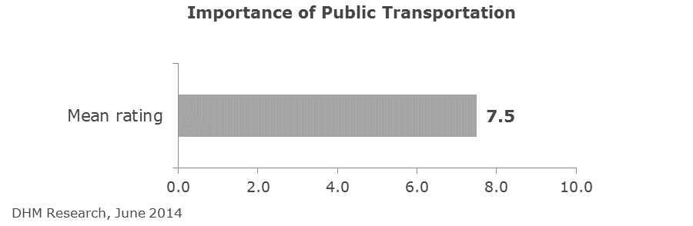Residents were recently asked to rate how important they feel public transportation is to the Eugene-Springfield area using a 0 through 10 scale, with 0 meaning “not at all important” and 10 meaning it’s “very important”. Chart 9 shows that residents gave a mean rating of 7.5 out of 10 to the importance of public transportation in the Eugene-Springfield area. Six in 10 (59%) gave a “top-box” rating of 8-10.

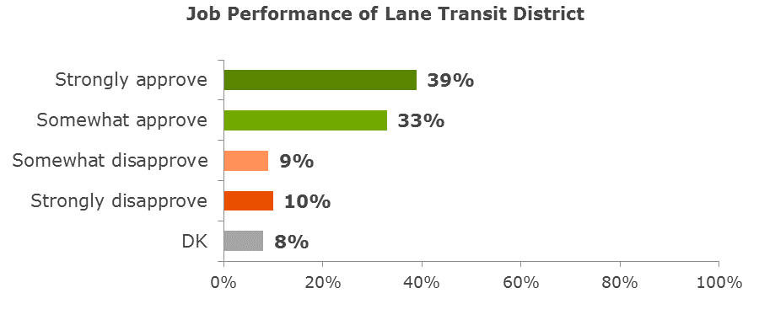Residents were informed that Lane Transit District provides public transportation services to the Eugene-Springfield area and surrounding communities. They were asked if they approve or disapprove of the job LTD is doing. As shown in Chart 10, More than seven in 10 (72%) residents approve of the job LTD is doing, with four in 10 (39%) who “strongly” approve. Two in 10 (19%) disapprove, split evenly between “somewhat” disapprove (9%) and “strongly” disapprove (10%). Similar approval ratings were observed in the 2013 TriMet Attitudes and Awareness Survey, where 66% approved of the job TriMet was doing.

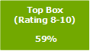

**Chart 9**

**Chart 10**

**Wrap-up**

In their book “Playing to Win: How Strategy Really Works”, AG Lafley and Roger Martin say that “strategy can seem mystical and mysterious, it isn’t. It is easily defined. It is a set of choices about winning.” In that context, strategy = choice - choices to do some things and not others. As a public agency, LTD makes choices that position us to create sustainable and superior value for the resources we are given.

The work we have done on articulating Why and How we do what we do addresses two of the foundational choices Lafley and Martin call for in the development of winning strategy:

1. What is our winning aspiration (Why we do what we do)? and
2. How will we win (How we do what we do)?

This foundation serves to help us cope with turbulence and uncertainty - reduce complexity by giving the board and staff a common frame of reference. This frame of reference can be used to organize information about our strategic context. It enables us to know what signals to look for.

**Not Knowing What We Don’t Know?**

One overarching and pervasive theme facing LTD, a framework theme, stems from the complex interplay of the many and vast systems of which we are a part. The natural environment, globalization of the economy, advances in technology or medicine, national politics, Oregon’s economy, social impacts of the income gap, local visions for growth and prosperity - all interact with each other and with the services LTD provides. As illustrated here, how each plays out in ways that will impact LTD is uncertain. It is the additional uncertainty surrounding how the interaction of these factors will affect LTD that creates a general ambiguity around the strategy development of LTD and its partners; in particular, decisions being made in the short-run that have longer-term effects (certain policies and capital projects related to our facilities and fleet).

Whether this is thought of as the Butterfly Effect or the old parable “for want of a horseshoe nail, a kingdom is lost,” the potential “crisis of crises,” and the ambiguity it brings, will frame the more specific strategic issues LTD must wrestle with in the coming years.

On a daily basis, we cannot reinvent daily operational protocols developed over decades of experience. From that standpoint, we need to assume that tomorrow is going to be pretty much like today. This makes it very challenging for us to connect our operations today to critical dynamics playing out over the next five years (let alone 10, 20 or 30 years).

This leaves us potentially vulnerable, not unlike the parable of the boiling frog. As the story goes, if you place a frog in a shallow pan of boiling water it will immediately try to jump out. But if you place the frog in warm water, and don’t scare him, he’ll stay put. If the heat is gradually turned up, the frog will stay in the pan, until it’s too late and he’s unable to climb out. The imagery is gruesome (and, according to Snopes.com, not true) but the lesson is clear. Like the frog, our internal systems for sensing threats to survival are geared to sudden changes, not to slow, gradual changes.

Addressing these challenges will require us to develop effective approaches to how we monitor and act on changes to our operating environment.

**Strategic Questions**

* **What do these broad dynamics and changes mean for LTD or for local government agencies?**
* **How do global events impact the local strategic environment?**
* **What larger events and uncertainties should LTD be paying attention to?**



1. Field Marshall Helmuth Carl Bernard Graf von Moltke (26 October 1800 – 24 April 1891)
2. Mayo, A. J., and N. Nohria. In Their Time. Harvard Business School Publishing Corporation, Boston, 2005.
3. The Institute for the Future. “Future Work skills 2020”, 2011.
4. Congressional Budget Office: “The Budget and Economic Outlook: 2014 to 2024”; February 2014