City hopes to enlist students, faculty to tackle planning projects

NEIL ZAWICKI Albany Democrat-Herald Feb 11, 2016
The Albany City Council has approved an application to let University of Oregon students and their professors come in to work on planning projects, through the University’s Sustainable City Year Program.

The council voted 5-1 in favor of the application at its Jan. 27 meeting, with Rich Kellum casting the dissenting vote.

The annual program selects one city and then provides 500 students from multiple academic disciplines, along with their faculty, to complete between 15 and 20 projects, ranging from parks planning to community outreach, for a total cost of about $250,000.

The 7-year-old program has included Medford, Salem, Gresham, Springfield, the greater Portland area and Redmond. If accepted as the next participant city, Albany’s program would begin in the late summer.

The funds for the program would come from money that has already been budgeted for city projects, City Manager Wes Hare said. At the Jan. 27 council meeting, Hare said he first considered applying for the program seven years ago, but thought it would be too expensive. This year, he said, his management team decided it would be a “relatively inexpensive way” to get some things done.

For the application, city department heads compiled a list of nine existing projects they would like the students and faculty to tackle, with a total price tag of $233,000.

The students would contribute 40,000 hours to such projects, which prompted councilor Bill Coburn to remark that it amounts to $5 per hour.

Kellum, however, had his doubts about the program.

“We’re talking about children and we’re talking about professors,” said Kellum. “And we’re going to pay those people to give us answers.”

He said the cost of bringing people up to speed ahead of any given project could be expensive, and not worth the time. He added that he’s “antsy” about giving people money to do things the city does not yet know it wants to do.

City of Albany Planning Manager Bob Richardson said the city doesn’t want to spend taxpayer dollars irresponsibly and has heard positive feedback from other planners who participated in the program.

He found that the students tend to be focused and goal-driven, which is valuable in the world of planning, where short-term priorities tend to push off the long-term projects, sometimes to the point they may not get done.

With this program, he said, the city could move some of those projects to the forefront.
“Once you have a dedicated group of students and faculty working on a project over 10 weeks, they can tend to focus on its completion,” he said.

Richardson said the 500 students would not necessarily be filling the rooms of City Hall. Rather, a few at a time would visit, get briefed on projects, and then bring them back to lab and classroom settings. He added that students tend to be much more enthusiastic about tasks, such as creating an interactive guide to Albany’s historic places.

“That’s a simple project that I think the students would love,” he said.

On the question of the students’ experience in the real world, Richardson said the ones who participate already have three or more years of training in their academic discipline.

“These are people I could potentially hire,” he said.

Of course, the question remains just how effective the program would be, should Albany be selected, and that’s where the experience of other cities can be instructive.

Medford Planning Director Jim Huber talked about his city’s participation in 2014. He said what stood out for him was the excitement the students brought to the projects. They completed 15 projects, ranging from a wayfinder program for city visitors, to an outreach program for the city’s Latino community.

“Compared to using outside consultants, we saved a bundle of money,” he said, but he added that consultants and other private firms were brought in for the next phases of some of projects the students launched.
On another level, the program can to become an economic net gain for a community. Courtney Busch is the strategic initiatives manager with the city of Salem. She said the program generated $1 million in unanticipated revenue for the city in 2011, when students were tasked with looking at the local business community to find ways to make biofuels from the waste products of different companies.

Busch said the students also looked at the city’s wastewater treatment facility and found a way to take the excess waste material there to create energy.

“They are steeped in innovative ways of thinking,” she said of the students. “It re-energized us around a series of solutions and had us thinking about things in different ways.”

http://democratherald.com/news/local/city-hopes-to-enlist-students-faculty-to-tackle-planning-projects/article_7f4f553c-3dd2-58e7-a6a5-32dc0370ad4c.html

UO students share vision for Albany downtown

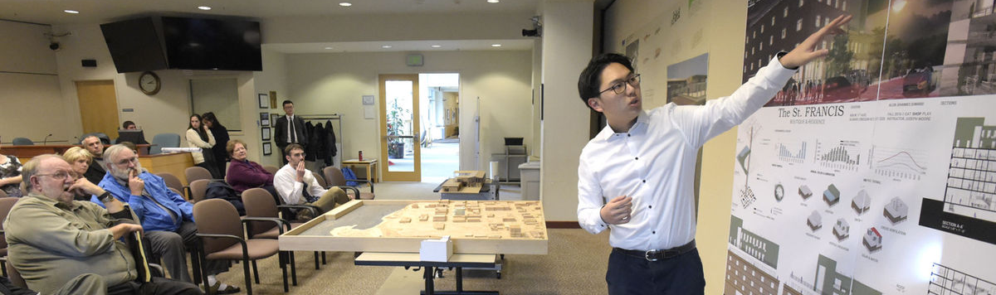

NEIL ZAWICKI Democrat-Herald Dec 7, 2016
University of Oregon architecture students on Wednesday presented ideas to Albany city officials concerning ways to revitalize the city's downtown area.
The presentations were part of the annual Sustainable Cities Year Program, which selects one city and then provides 500 students from multiple academic disciplines, along with their faculty, to complete between 15 to 20 projects for that city, ranging from parks planning to community outreach, for a total cost of about $250,000.
The 7-year-old program has included Medford, Salem, Gresham, Springfield, the greater Portland area and Redmond. Albany’s program began in late September.
The students were charged with designing plans to repurpose the J.C. Penney building, the downtown post office and the St. Francis Hotel. Keeping with the theme "Eat, Shop, Play," they shared their designs for a multi-use market and dining venue, a performing arts center, and a mixed-use shopping and residential building, respectively.
Student Steven Liang shared his plans for the J.C. Penney building: a shopping and dining venue with space for farmers markets and rooftop areas for socializing.
"My goal was to energize and vitalize the Water Avenue area," he said, adding that he wanted to design a picture of a congruous city.
Next up, student Alan Zandy showed his concept for the hotel, which was a mixed-use shops and apartment space with an open atrium in the center and rooftop areas for socializing and garden space.
Both students were asked what their projects would cost, and being architecture students, both explained that the scope of their classroom projects did not allow for such calculations. When Albany resident Hasso Hering pressed for a ballpark figure, Zandy replied, "A lot of money."
His response brought down the house.
Concerning the post office, student Karin Ziv shared her concept for a performing arts center that would seat between 300 and 400 people, and accommodate a restaurant and studio spaces. The round, almost Frank-Gehry-style venue would stand adjacent to the Albany Historic Carousel & Museum. For this reason, Ziv designed landscaping areas that would attract visitors to and from both venues.
"I like to design for a specific location," she said. "So if I pick it up and plop it down in another location, it wouldn't really work the same. So I think this center would work very well, and I would be really excited should you decide to build it."
While the students were allowed to design free of any real budget constraints, bring their ideas to fruition, in one form or another, is possible, according to parks and recreation Department Director Ed Hodney.
"Because these new ideas are so exciting, it turns us in different directions," he said. "This is an opportunity to bring some very creative and youthful ideas. For my part, this has been extremely energizing, and it's still fairly safe because we haven't committed to buying anything."
http://democratherald.com/uo-students-share-vision-for-albany-downtown/article_7732fcad-cdeb-50bd-a493-3cb72b15fe7d.html

UO students to present project details
Kim Jackson, March 14th, 2017
Students at the University of Oregon who are participating in the Sustainable City Year Program in partnership with the city of Albany will present their plans March 14-22 for a variety of community projects.
The public is invited to attend the presentations, in both Albany and Eugene.
The projects involve Albany parks, natural areas, the waterfront, downtown, historic preservation, and community buildings.
Presentations at Albany City Hall, 333 Broadalbin St. SW, are scheduled for Friday, March 17. They include:
• 10 a.m.—St. Francis Hotel viability.
• 10 a.m.—Business plan and marketing campaign for Albany Parks & Recreation Foundation.
• 1 p.m.—Strategic plan to serve older adult population.
• 2 p.m.—Strategic plan for collaborative sports facilities provision and management.
3 p.m.—East Thornton Lake Natural Area – reinterpreting culture and nature as productive infrastructure.
Other presentations will be on the University of Oregon campus in Eugene on March 14, 15, 16, and 22. Topics include historic waterfront and downtown mapping, improving civic and community engagement, equity and opportunity mapping analysis, advanced cartography parks mapping, and passive heating for community buildings.
The Sustainable City Year Program links students with an Oregon city, county, special district, or partnership of governments for an entire year. The Albany projects involve architecture, geography, landscape architecture, public relations, and business students.
http://democratherald.com/news/local/uo-students-to-present-project-details/article_e5a9a3ab-43d3-55c1-81cd-1e16bdb51d96.html

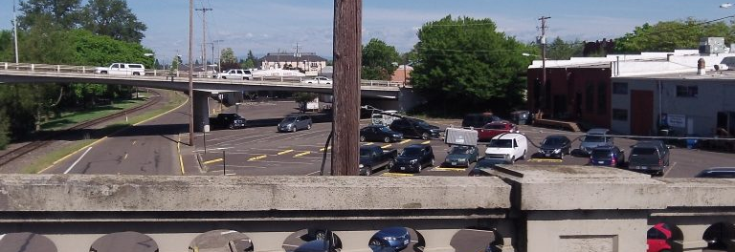
This is where a downtown plan envisions some kind of development.

What about that ‘east anchor’?
Written August 17th, 2016 by Hasso Hering

Five years ago, an update of Albany's downtown plan called for two "anchors" to help revitalize the central area. On the west end, there would be the Albany Carousel, now under construction. On the opposite end, there would be an unspecified "east anchor" on the south side of Water Avenue between the Willamette River bridges. It's still a city-owned parking lot, though, and nothing else has come up.

The east and west anchors were part of the "retail refinement plan" commissioned in 2011 for the Central Albany Revitalization Area, the downtown urban renewal district. The plan by long-time CARA consultant George Crandall and his firm called for several big private and public developments, but only the carousel is becoming a reality so far. As for the east anchor, the 2011 plan envisioned it as "a major development opportunity site, ideally suited for a high retail traffic generator along the Ellsworth/Lyon corridor."

To help with the idea of the east anchor, city officials once proposed a "slip lane" that would allow drivers to get to Water Avenue from the right lane of one-way Lyon Street before having to head across the river. But ODOT discouraged this idea.

What about the east anchor now, I asked Kate Porsche, the city's urban renewal manager and economic development director. Her emailed reply: "We are still exploring the idea and working to understand if it’s a viable site and how it would function without the slip lane. To that end, one or two of the U of O classes this year may work on looking at that site as part of their work for the SCI program. We’re still firming up and matching courses to projects so I don’t yet know what exactly this will look like."

SCI stands for the University of Oregon's Sustainable Cities Initiative, a program that pairs students and faculty with local governments that want help with projects. Albany has agreed to take part in the program this coming academic year.

So as you can see, the idea of downtown Albany's east anchor has not advanced since being proposed five years ago, and unless something happens the site likely will remain a parking lot for a while. (hh)

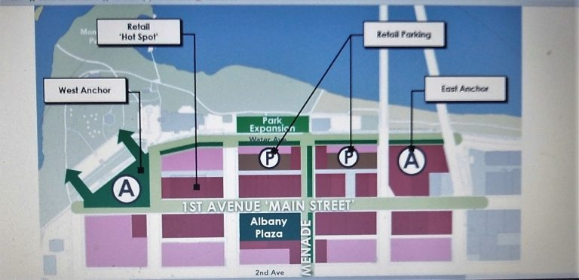
The Refinement Plan map showed the anchors as "A."

http://hh-today.com/what-about-that-east-anchor/

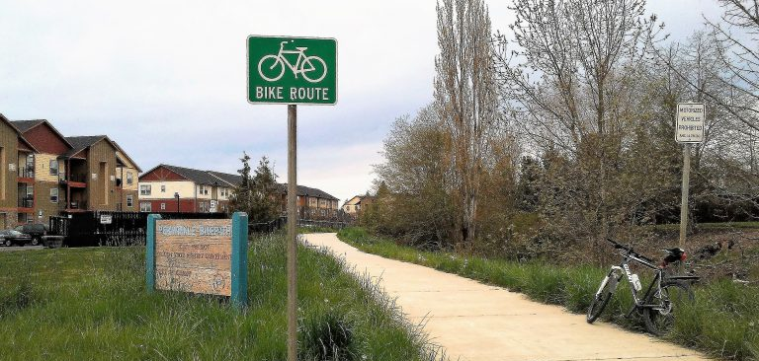
The Periwinkle Bikepath near Queen Avenue. More than 40 years ago, OSU students had a hand in bringing it about.

Students tackle bike path study
Written April 18th, 2017 by Hasso Hering

It was in 1973 that that a group of seniors at Oregon State University had an assignment of designing bikeways for the city of Albany, and the Periwinkle Bikepath was the result. Now another group of students, from the University of Oregon this time, has taken on a similar challenge. It may be too much to expect a similar result.

In a letter to the editor of the Albany Democrat-Herald in 2008, Tom Uppstad recalled the Periwinkle work he and his fellow OSU seniors did in the 1970s . "The goal was to provide an alternative route to travel with minimal competition with motor vehicles," he wrote. And with a couple of exceptions -- at Queen and 21st avenues -- the 1.7-mile Periwinkle bike route manages to do so, even though it falls short of the original goal, which was to run from South Albany all the way to the Willamette River.
Now, U of O students are taking a look at another waterway, the Santiam Canal as it flows through Albany. They are taking a course titled "Topics in Bicycle Transportation" taught by Marc Schlossberg, professor of planning and co-director of the university's Sustainable Cities Initiative. As part of that initiative, several classes and faculty members have been studying Albany issues identified for them by the city staff.
The students tackling the bike project are in a class on the planning of "canal multi-use paths." Last week they met in Albany and took a look at what was what. They're supposed to "analyze previous plans and assess constraints and barriers to development around the Albany-Santiam Canal... Recommendations could include next steps for development, recommendations for project phasing, and project design details."
A tall order, that. Especially considering those "constraints," which include long-standing objections to any recreational development along the path from Public Works and, probably, property owners along the way.
The Town Center Plan that emerged from the Central Albany Land Use and Transportation Study in the 1990s recommended that walking paths be developed along the Santiam Canal, but it has not been done. And as a bikeway such a path would be impractical because cyclists would have to stop for cross streets on every block.
The Periwinkle path planners had no such problems. The route along the channelized creek was open and uninterrupted, as much of it remains today. (hh)
http://hh-today.com/students-tackle-bike-path-study/

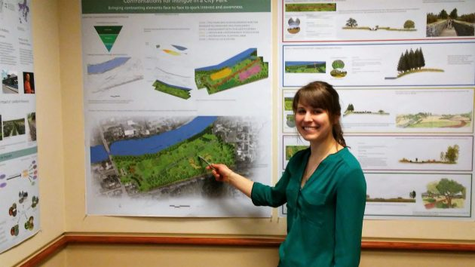
Brianna Heese, a grad student from Missouri, incorporated elements of Oregon history in her concept of the landscape design.

Diverse ideas for new ‘natural area’

Written March 17th, 2017 by Hasso Hering
It took each of 13 graduate students in landscape architecture only a few weeks to come up with a different concept of how Albany might some day develop the East Thornton Lake Natural Area. They got the assignment in January, and on Friday they showed their plans to a small but appreciative audience at City Hall.
The students are in the first year of their master's program in landscape architecture at the University of Oregon. Their class took part in the Sustainable City Year Program, a partnership with the city of Albany to study and make recommendations on all sorts of issues identified by the city.
Ed Hodney, parks and recreation director, said the students' work represented an "incredible array of ideas." Their concepts may come in handy once the city hires a consultant to draft a master plan for the East Thornton Lake acreage.
Albany bought the 27 acres of former farmland on the south bank of East Thornton Lake in 2009 for $2.25 million from a Salem developer. Neighbors had fought the developer's plans for a big subdivision there, and the city purchase ended the land-use fight. In complexity and imagination, some of the students' proposals seemed to go beyond the thought when the land was bought that the area be left mostly natural, as the name implies. But this was an assignment, so they showed more innovation and creativity than you'd think are necessary to leave a natural area alone.
One design called on visitors to engage with the history of the valley. Another called for a pattern of paths that resembled the historical flow of the Willamette River. One suggested trees with edible fruit. Another included symbolic references to neighbors trusting each other, and one carried out the notion of balancing acts. It was all quite imaginative, and the graphics illustrating the presenters' spoken summaries of each concept drove home their points. It was dazzling enough to prompt one lakeside resident to say it deserved a "standing ovation."
Other student groups in the program had studied other projects, including one to provide "collaborative sports facilities," and presented their conclusions during the last few days. I missed those, but you and I can hope for the details if and when the university or the city publishes a summary of the entire program when the Sustainable City Year ends after spring term. (hh)

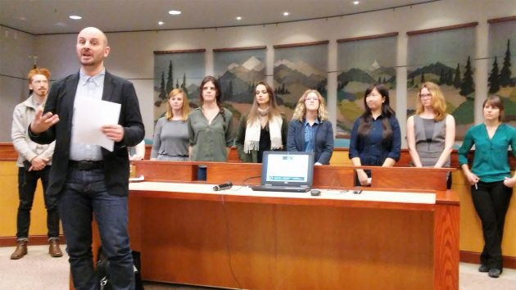

Instructor Jacques Abelman and some of his landscape design students in the Albany project.
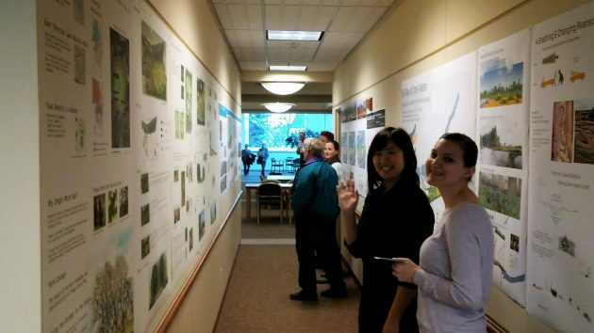
Some of the concept-explaining posters were displayed in the upstairs hallway at City Hall.
http://hh-today.com/diverse-ideas-for-new-natural-area/

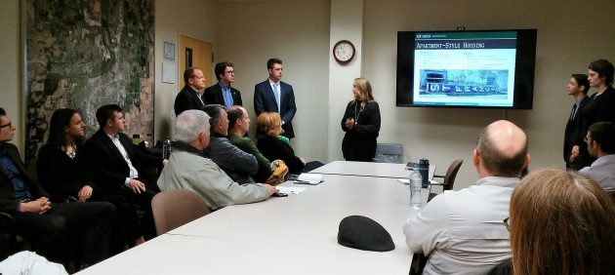
Students present their analysis of renovating the old St. Francis for apartment housing.

St. Francis fix: ‘Financially unfeasible’
Written March 17th, 2017 by Hasso Hering

Renovating the former St. Francis Hotel in downtown Albany is not financially feasible, two groups of students at the University of Oregon have concluded after a thorough analysis of the costs and potential returns.
Fifteen students in fields such as business, economics, marketing and finance presented their findings at City Hall on Friday. They analyzed the prospects of renovating the roughly 40 rooms on the upper three floors as apartments and the ground floor as a business location. Even after taking into account a variety of federal, state local aid programs, they concluded that both propositions were out of the question now from a business standpoint. The cost of buying the building and restoring it would be too great in comparison to what a new owner or investor could expect as revenue in return.
The historic former hotel at First Avenue and Ferry Street houses Pride Printing on the ground floor, and the upper three floors have been vacant except for storage since the 1960s. The owners of the print shop own the building, which is free of debt, and they are not eager to sell or move.
As for the apartment idea, the students in the first group suggested holding off doing anything other than small repairs to keep the building from deteriorating further. Then a purchase and renovation could be reevaluated in 10 years if market conditions have changed. On the ground floor, the second group's recommendation was to do nothing, leaving the print shop to continue, because commercial redevelopment is not financially feasible. If it was, they suggested a brewpub.
Analyzing the business aspects of renovating the building was part of the university's Sustainable City Year Program. The city of Albany is paying the U of O about $250,000 to have faculty and their classes in architecture, business and other fields study issues in which the council and other city groups are interested. Having someone buy and restore the old St. Francis, pushing forward with Albany's downtown renewal, is one such idea.
City Councilmen Rich Kellum and Ray Kopczynski attended the St. Francis briefing, as did several city officials and other locals. If any of them were surprised to hear this kind of cold look at hard numbers from U of O students -- all soberly dressed in business attire -- it didn't show. (hh)
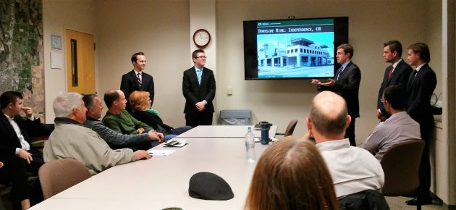
The group cautioned against a flop like Independence Station, the unfinished building shown on the screen.
http://hh-today.com/st-francis-fix-financially-unfeasible/

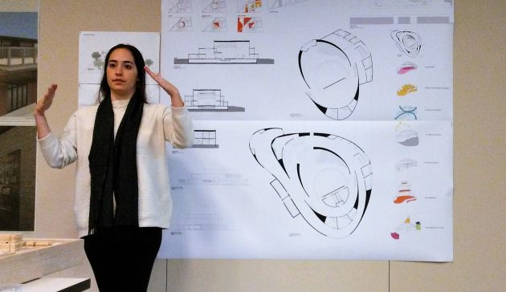
UO student Karin Ziv talks about her concept of a downtown performing arts center Wednesday.

Students offer daring downtown designs

Written December 7th, 2016 by Hasso Hering
Architecturally speaking, downtown Albany would be a more exciting place if there was a way to carry out any of several redevelopment designs worked up by students at the University of Oregon.
About a dozen UO students -- from Oregon, other states and abroad -- presented their ideas at City Hall Wednesday afternoon. They developed them during fall term in a design studio class taught by Joseph Moore. They and students and faculty in other classes at the university are spending this school year working on Albany projects as part of a UO program called the "Sustainable Cities Year."
Moore's architecture students had an assignment: Come up with designs of how three downtown sites could be redeveloped. The sites are the former St. Francis Hotel, the post office block, and the city parking lot behind the old Penney's Building.
Allen Suwardi's concept for the St. Francis would preserve the four-story historic building's façade but gut the interior and construct a seven-story addition to provide hotel rooms, apartments, other uses and even a terrace that would serve as green space. The students were not supposed to worry about economics, and asked how much his concept would cost to carry out, Suwardi hesitated and then said, "A lot of money."
A few years ago a Portland development company proposed to remodel the building as workforce housing at a cost then estimated at $10 million.
Other students presented less ambitious ideas for the St. Francis. One said her approach was to keep the original interior structure and build a number of apartments or units for short-term stays by combining adjoining former hotel rooms and turning some bathrooms into kitchens.
Student Karin Ziv's idea was to build a performing arts center, consisting of sweeping curves outside and in, on the site of the Albany Post Office. Her design had an auditorium for 300-340 people as well as a restaurant and space for other uses, including art galleries. There's no indication the post office has any plans to leave its leased building and grounds, but if Albany keeps growing the Postal Service may have to change sites eventually.
For the city-owned parking lot between the remodeled Penney's Building and Water Avenue, students presented several concepts for turning the property into a combination market-restaurant-business center. Steven Liang's design called for, among many other things, space for a permanent farmer's market facing Water Avenue.
How about parking, city officials wondered. Some of the student designs featured underground parking. But If anything like these ideas are ever carried out and bring in hundreds more people and vehicles downtown, a parking structure likely is inevitable.
The UO-Albany partnership continues for the rest of the academic year. Students in a variety of disciplines are also tackling tasks such as master planning for city parks and developing ideas for rejuvenating Water Avenue and the riverfront. (hh)

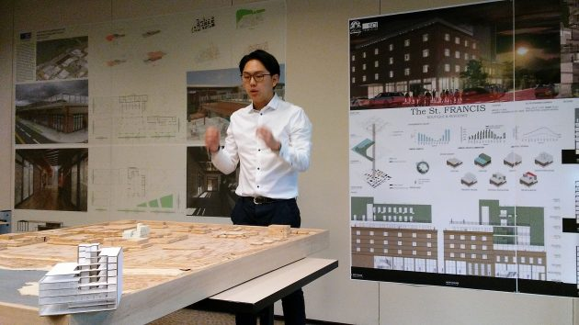

Allen Suwardi’s St. Francis design in drawings, behind him, and two models, one on its site in plywood mockup of downtown, the other in the left foreground.

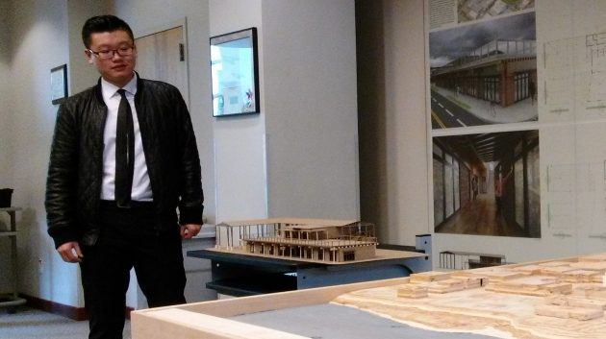
Steven Liang with a model of his idea for a market building facing water Avenue.
http://hh-today.com/students-offer-daring-downtown-designs/

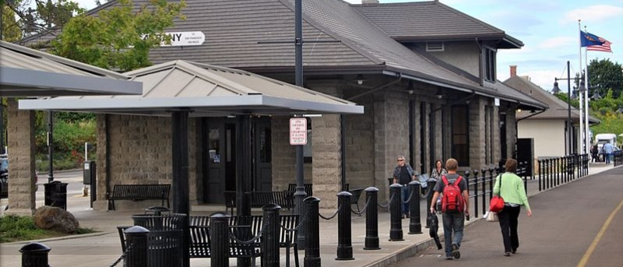

UO to partner with Albany on more than 20 civic projects
May 26th, 2016 – 6:00am
The University of Oregon’s Sustainable City Year Program will be back in the Willamette Valley this year, this time in partnership with the city of Albany.
The city and the University of Oregon are planning 20 different projects for the 2016-17 academic year, ranging from economic development to parks and recreation planning. Beginning in September, students from more than 10 disciplines at the UO will work closely with the Albany community over the next year.
Albany Mayor Sharon Konopa said she is “excited to work with students and faculty at the University of Oregon and see what their creative minds bring to Albany. Albany has a wonderful opportunity this year to engage hundreds of students and professional faculty to take a fresh, cost-effective look at projects that the city has already planned and funded but staff has not had time to complete.”
More than 25 universities and schools in the U.S. and several other countries have adapted the Sustainable City Year Program model. The program is part of the Sustainable Cities Initiative, a cross-disciplinary organization at the UO that promotes education, service, public outreach and research on the design and development of sustainable cities.
“This program exemplifies our mission as a public research university to foster discovery, teach future leaders and serve our communities,” UO President Michael Schill said. “Our students benefit from this rich experiential opportunity to put their knowledge to work, and our communities benefit by identifying ways to revitalize their economic vitality in a sustainable way."
Now in its seventh year, the Sustainable City Year Program links UO students with an Oregon city for an entire academic year. Each year, the partner city receives assistance with projects centered on sustainability through the work of student classes across the university.
In a typical year, more than 400 students from 12 disciplines across 30 classes work on 20 partner-directed projects. At the end of the year, more than 40,000 student hours of work will have been devoted to helping a city transition to a more sustainable future.
Albany staff members are looking forward to student insight on highly anticipated projects, Konopa said, including the development of a concept plan for Willamette riverfront parks and trails that will assess management options for several hundred acres of riparian open space. Another important project will be a downtown catalyst project that will investigate potential for retail development in the east end.
For their part, Sustainable Cities Initiative staff said they are excited to work with a forward-thinking city with great leadership.
“We are thrilled to be partnering with Albany this year; the city has put together a fantastic list of projects that will work across numerous departments,” said architecture professor Nico Larco, the SCI co-director. “SCYP Albany will push forward shared goals of improved quality of life for residents and efficiency in government.”
https://around.uoregon.edu/content/uo-partner-albany-more-20-civic-projects

UO - School of Architecture and Allied Arts

UO to work with City of Albany in 2016-17 in partnership with the Sustainable Cities Year Program
Wednesday, June 8, 2016
The University of Oregon’s Sustainable City Year Program (SCYP) will be working once again in the Willamette Valley, this time in partnership with the City of Albany.
The City and the University of Oregon are planning twenty different projects for the 2016-17 academic year ranging from economic development to parks and recreation planning. Beginning in September, students from more than ten disciplines at the UO will work closely with the Albany community over the next year.
Albany Mayor Sharon Konopa said she is “excited to work with students and faculty at the University of Oregon and see what their creative minds bring to Albany. Albany has a wonderful opportunity this year to engage hundreds of students and professional faculty to take a fresh, cost-effective look at projects that the City has already planned and funded but staff has not had time to complete.”
More than twenty-five American universities and schools in several other countries have adapted the Sustainable City Year Program model. SCYP is part of the Sustainable Cities Initiative (SCI), a cross-disciplinary organization at UO that promotes education, service, public outreach, and research on the design and development of sustainable cities.
“This program exemplifies our mission as a public research university to foster discovery, teach future leaders, and serve our communities,” UO President Michael Schill said. “Our students benefit from this rich experiential opportunity to put their knowledge to work, and our communities benefit by identifying ways to revitalize their economic vitality in a sustainable way."
Now in its seventh year, the SCYP links UO students with an Oregon city for an entire academic year. Each year, the partner city receives assistance with projects centered on sustainability through the work of student classes across the university.
In a typical year, more than 400 students from twelve disciplines across thirty classes work on twenty partner-directed projects. At the end of the year, more than 40,000 student hours of work will have been devoted to helping a city transition to a more sustainable future.
Albany staff are looking forward to student insight on highly anticipated projects, Konopa said, including the development of a concept plan for Willamette riverfront parks and trails that will assess management options for several hundred acres of riparian open space. Another important project will be a downtown catalyst project that will investigate potential for retail development in the east end.
For their part, SCI staff said they are excited to work with a forward-thinking city with great leadership.
“We are thrilled to be partnering with Albany this year— the City has put together a fantastic list of projects that will work across numerous departments,” said Nico Larco, SCI co-director. “SCYP Albany will push forward shared goals of improved quality of life for residents and efficiency in government.”

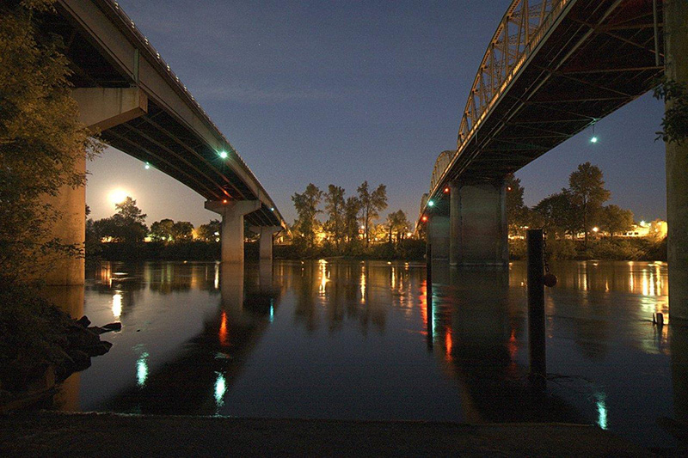
Above: Two bridges cross the Willamette River in Albany, Oregon. The Ellsworth Street Bridge was built in 1925 and carries U.S. Route 20 eastbound traffic. The Lyon Street Bridge, built in 1973, carries westbound traffic and connects Albany with North Albany and is a major link between Albany and Corvallis, Oregon The Ellsworth Street bridge was designed as a steel-truss bridge by Conde McCullough, the state’s highway bridge designer.

Story by Megan Banks, Sustainable City Year Program Director

https://aaa.uoregon.edu/news/uo-work-city-albany-2016-17-partnership-sustainable-cities-year-program

UO - School of Architecture and Allied Arts

UO launches sustainability partnership with City of Albany
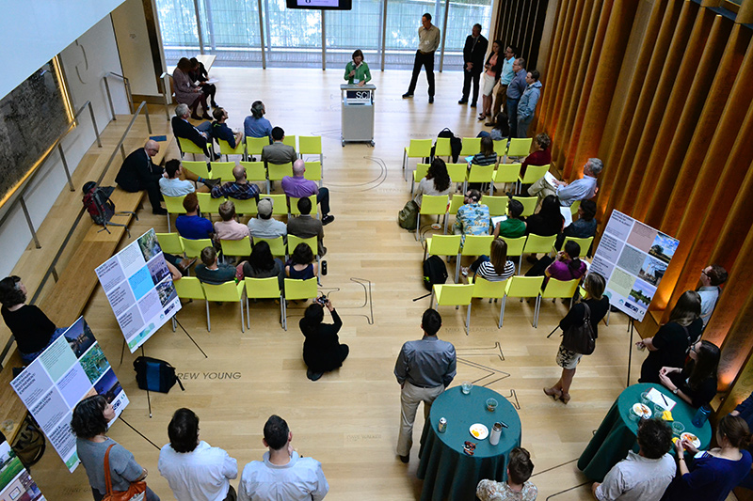
Above: Dyana Mason, assistant professor in the Department of Planning, Public Policy and Management, addresses those gathered to celebrate the SCYP year with Albany. Mason is teaching “Nonprofit Consultancy,” a capstone course for Masters in Nonprofit Management students. In spring 2017, the students will work with the City of Albany to support its new Parks & Recreation Foundation and the Senior Center Foundation. Photos by Marti Gerdes.

Wednesday, November 2, 2016
A&AA Dean Christoph Lindner moved from The Netherlands to Eugene in summer 2016 partly due to a program established at the UO.
“One reason I uprooted my life from Amsterdam and came to Eugene included the Sustainable Cities Initiative,” Lindner told a crowd gathered in the Jaqua Academic Center for Student Athletes to kick off the SCI’s 2016–17 collaboration with the City of Albany, Oregon.
“It is truly special on a global scale,” Lindner said of the SCI. “There’s great diversity of expertise in a university, but very rarely can we bring those [diverse areas] together. SCI does that.”
Under the SCI umbrella, the Sustainable City Year Program (SCYP) annually partners hundreds of students and faculty with an Oregon city seeking sustainability-focused solutions to civic concerns. Students and faculty will pour roughly 40,000 hours of work into the chosen city.
Faculty in the UO’s Departments of Architecture and Planning, Public Policy and Management developed SCYP in 2009. Since then, SCYP has worked with Redmond, Medford, Salem, Springfield, and Gresham.
The large-scale university-community partnership model has since been adopted throughout the US and internationally, including at Technion-Israel Institute of Technology in Haifa.
Given its reach, the program has plenty of enthusiastic supporters.
“As an alumnus, I am proud to note the University of Oregon Sustainable City Year Program model has been adopted by more than 25 universities,” Congressman Peter DeFazio said in a statement read at the UO event by his district director, Dan Whelan.
Albany Mayor Sharon Konopa was raised in Albany when “it was fun and vibrant,” she said. “Then in the ’80s and ’90s things became blighted.” She anticipates SCYP will reanimate Albany “to help us get to another level” with projects including riverfront parks and trails and downtown retail development.
SCYP participants include students from schools and colleges across the UO, from the College of Arts and Sciences and the Lundquist College of Business to the School of Architecture and Allied Arts and the School of Journalism and Communications (SOJC).
During fall term 2016, A&AA students in PPPM, architecture, and arts administration will engage with Albany in downtown redevelopment, parks and recreation funding, and community engagement. Later in the year, A&AA students will work with Albany on projects ranging from multi-use paths on canals to parks planning and expansion.
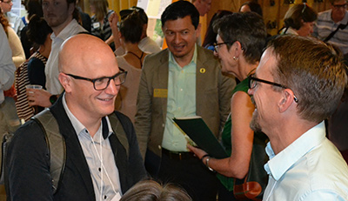
Above: A&AA Dean Christoph Lindner (left) talks with Rich Margerum, professor in the Department of Planning, Public Policy and Management about projects for SCYP Albany. Juan-Carlos Molleda (background, in green shirt and tan jacket), dean of the School of Journalism and Communications, talks with City of Albany Public Information Officer Marilyn Smith.

Story by A&AA Communications

https://aaa.uoregon.edu/news/uo-launches-sustainability-partnership-city-albany

School of Architecture and Allied Arts

Historic hotel inspires adaptive designs for SCYP project
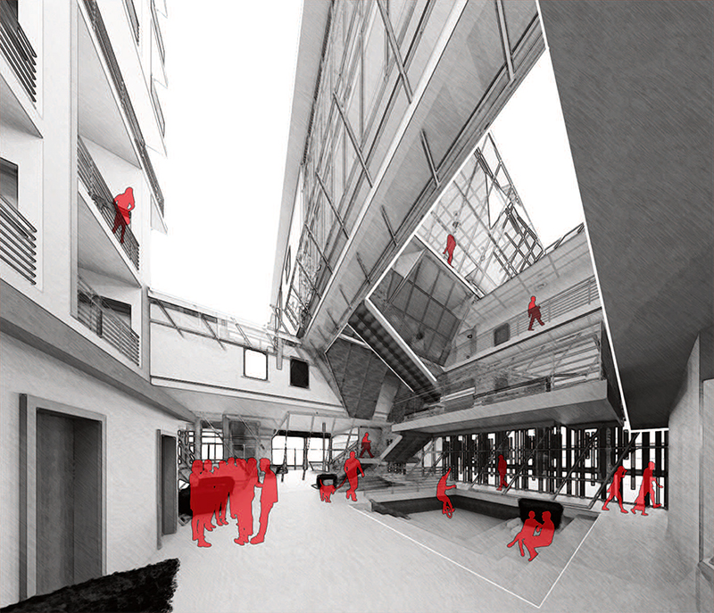
Above: Undergraduate architecture student Kevin So’s re-envisioning of St. Francis Hotel. All images courtesy Megan Banks.
Tuesday,May 16, 2017
When UO architecture undergraduate Shirley Huang had a chance to work on a real-life design project for the City of Albany, she was initially seeking practical experience. City officials thought the former St. Francis Hotel might be adapted to support housing or return to use as a hotel. Through an architecture studio course at the UO, Huang hoped to give city officials some options to implement their vision.
But after taking a tour of the 1912 building, which is listed on the National Register of Historic Places, she became more inspired. The four-story downtown building has been three-quarters vacant since the 1960s, with a printing company occupying the ground floor and the top three floors mostly unused. Huang wanted to see it come back to life as an updated version of its original use—a downtown hotel.
“The key features are still there, and especially the first floors are pretty well-maintained,” she said. “The other floors have cedar flooring and the wallpaper was beautiful, really colorful.”
Huang realized that structural changes were needed. “It’s not immediately useful as a hotel just by adding furnishings,” she said.
In 2012, the hotel was listed as one of the state’s “most endangered places” by the Historic Preservation League of Oregon, prompting new discussions on ways to save it.
To match the city’s vision for a mixed-use design, accommodating retail or business space and dwelling units, Huang decided it would be ideal to preserve the building’s still-attractive structure. To update it, she created a unique design that includes both hotel and apartment spaces. “I think the building should have the ability to provide all those options,” she said.
That’s exactly the kind of perspective Albany officials wanted when they partnered with the Sustainable City Year Program at the University of Oregon to develop ideas and concepts that further the city’s vision for its historic downtown.
“We’re buying brainpower and ideas and a fresh approach that are uncorrupted by a paycheck,” said Ed Hodney, director of Albany’s Parks & Recreation department and acting director of the city’s Economic Development/Urban Renewal department.
Huang was one of four students in the design studio led by architect Joseph Moore that focused on the St. Francis Hotel during fall term 2016 as part of the SCYP.
Moore, principal at GMA Architects in Eugene, wanted students to consider the city’s vision for the hotel and its relationship with the rest of the environment.
“You’re getting all of these connections, and it’s just so much more fruitful or interesting for the students to be involved and to see that all of these things are related, and to start navigating those worlds early,” Moore said.
In December, Moore’s students presented their design concepts to City of Albany officials.
“It’s a piece of a conceptual vision that’s been developed over the last several years, and we’re now giving some form to those ideas,” said Bob Richardson, Albany’s planning manager.
The St. Francis Hotel renovation is only one of several initiatives the SCYP is helping Albany research and conceptualize, thanks to the UO-City of Albany collaboration this academic year.
“This partnership is all about generating ideas and possible strategies and projects that city staff simply don’t have the time and the resources to pursue,” Hodney said.
“It will increase our capacity to think creatively toward the solution to a myriad of issues and problems that the city is going to have to tackle at some point or another.”
Albany Mayor Sharon Konopa is pleased with what she’s seen from students.
“I have been amazed over the projects the students have worked on so far. The architectural designs for our historic downtown were not only creative but a wonderful fit for our community,” she said. “The students looked toward the future when it came to their creations.”

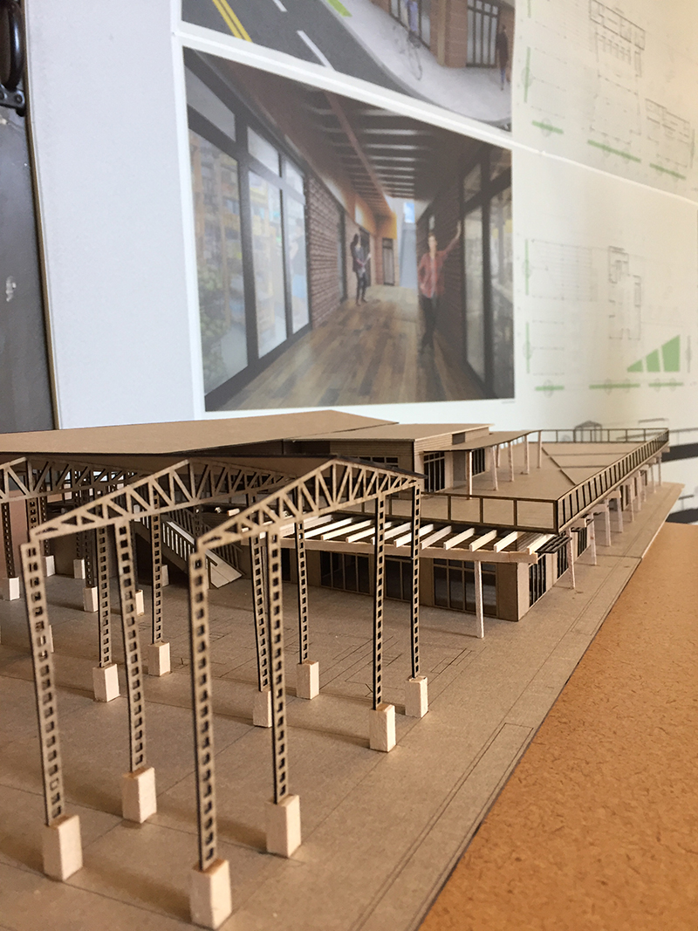
Above: Student Steven Liang’s model and visual interpretations of the hotel redesign.

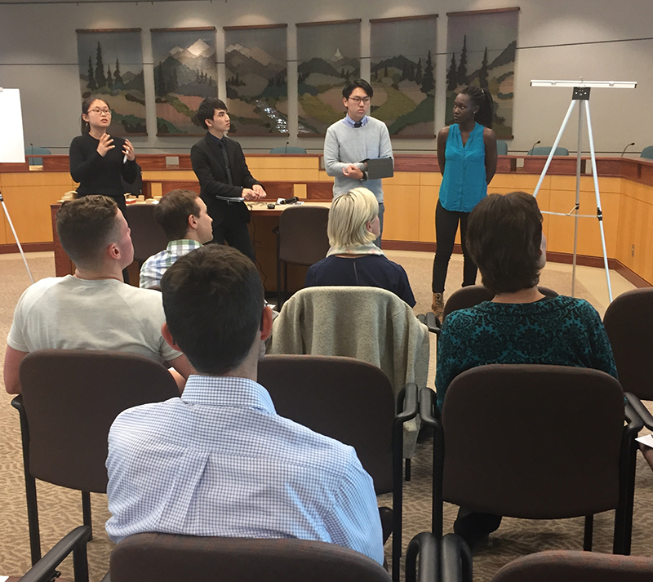
Above: Students Shirley Huang (from left), Kevin So, Allen Suwardi, and Sharon Alitema present their research to the City of Albany.Students Mia Ashley (from far left to right) Steven Liang, Luke Janzen, and Camden Santo discuss their project.

Story by Josie Fey, School of Journalism and Communication graduate student.

https://aaa.uoregon.edu/news/historic-hotel-inspires-adaptive-designs-scyp-project

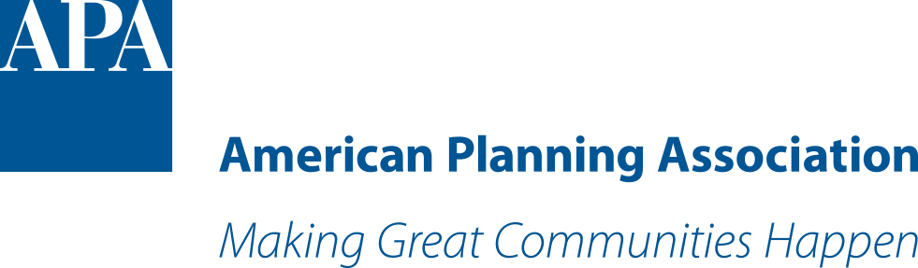

The Oregon Model

By Chloe Meyere
Nearly 10 years ago, University of Oregon planning professor Marc Schlossberg and architecture professor Nico Larco had a groundbreaking idea: What if a city could harness the creativity of university students and apply it to the problems planners face?
"What if" became reality in 2007 when the pair founded the Sustainable Cities Initiative, the University of Oregon's think tank for sustainable progress.
SCI's annual partnership, the Sustainable City Year Program, connects students with nearby cities in need of pragmatic solutions. Today, the program enlists nearly 400 students — largely future planners — from 30 classes, and has worked in Salem, Gresham, Springfield, Redmond, Medford, and Albany, and with TriMet, Portland's public transit agency.
Jim Huber, AICP, the planning director of Medford, explains how the partnerships work: "Our fire department is going to build two new fire stations. [SCYP] classes came up with a variety of different kinds of designs," he says. "The fire department and firemen could articulate what they needed, and students received valuable education."
That hands-on experience is why KC McFerson, a law and planning graduate student, chose UO. "The opportunity to apply theoretical knowledge to a real-world project helps me as a student by building connections, and helps me as a person who's passionate about creating change in the world," she says.
SCI's success hasn't gone unnoticed. Schlossberg and Larco were consulted by other universities and communities looking to adopt similar programs. Now, the Educational Partnerships for Innovation in Communities Network — also known as "the Oregon Model" — has been implemented by 30 universities across the U.S.
It's gaining international attention, too. In May, the U.S. Environmental Protection Agency and the United Nations sponsored a one-day, 40-country SCI workshop in Bonn, Germany — a reminder that leaders around the world recognize the importance of collaboration in fostering sustainable progress at the local level.
"To create a successful project and garner [support] from a diverse set of team members, it's important to understand everyone's perspective. SCYP was my first foray into understanding and practicing this dynamic," says Jessica Bloomfield, a former SCYP law and planning student and current Washington, D.C., land-use attorney.
"Students think they can change the world, while many professionals are burdened by time constraints, understaffing, budgets, unimaginative policies, etc., and can lose sight of the big picture," she adds. "Let them do it."
Chloe Meyere is the press and communication coordinator for the Sustainable Cities Initiative, and recently received her Bachelor of Science degree from the University of Oregon.

https://www.planning.org/planning/2017/jun/forbetter/

UO students offer Albany ideas for communicating historic home renovation process

What if you could crowd source city planning ideas from soon-to-be professionals in the fields of architecture and communications, before spending resources an official project?

That’s exactly what the city of Albany has done with the Sustainable City Year Program (SCYP) at the University of Oregon, a program that fosters a one-year partnership between students across disciplines, with a city in Oregon. The partnership allows the city to present real problems they face, and in response, the students provide pragmatic and target-oriented solutions for sustainability and revitalization.

Said Ed Hodney, Albany’s director of parks and recreation and interim director of urban renewal, “We’re buying brainpower and ideas and a fresh approach that are uncorrupted by a paycheck.”

Here are two examples of how they were able to gather inspired, progressive ideas for whether or not to preserve a vacant hotel and how to effectively communicate preservation techniques and requirements to historic homeowners.

Preserve history, or start anew?

When Shirley Huang, a senior architecture student at the University of Oregon, had a chance to work on a real-life design project for the city of Albany, she was at first looking for practical experience. The city was interested in understanding how the St. Francis Hotel building might be adapted to support housing or a hotel. And through a class at the university, Huang could give city officials some possibilities for how to implement their vision.

Huang became inspired by the style of the historic building after taking a tour. She wanted to see it come back to life as an updated version of its original purpose.

“The key features are still there, and especially the first floors are pretty well-maintained,” she said. “The other floors have cedar wood flooring and the wallpaper was beautiful; it was really colorful.”

Huang noted, however, that structural changes would have to be implemented. “It’s not immediately useful as a hotel just by adding furnishings to it,” she said.

To match the city’s vision for a mixed-use design, accommodating retail or business space and dwelling units, Huang decided it would be ideal to preserve the building’s already attractive structure. To update it, she created a unique design that includes both hotel and apartment spaces. “I think the building should have the ability to provide all those options,” she said.

Huang was one of four students in an SCYP design studio class led by Eugene architect Joe Moore that focused on the St. Francis Hotel project during the fall term.

Moore wanted students to consider the city’s vision for this portion of the project and its relationship with the rest of the environment.

“You’re getting all of these connections, and it’s just so much more fruitful or interesting for the students to be involved and to see that all of these things are related, and to start navigating those worlds early,” Moore said.

During a meeting in December 2016, Moore’s students presented their design concepts to city officials. Bob Richardson, Albany’s planning manager, said they would take these ideas and determine what’s next.

“It’s a piece of a conceptual vision that’s been developed over the last several years, and we’re now giving some form to those ideas,” Richardson said.

The St. Francis Hotel renovation is only one of the many initiatives the SCYP will address; a shortage of capacity at the city level makes the partnership ideal, Hodney said.

“This partnership is all about generating ideas and possible strategies and projects that city staff simply don’t have the time and the resources to pursue,” Hodney said. “It will increase our capacity to think creatively towards the solution to a myriad of issues and problems that the city is going to have to tackle at some point or another.”

Mayor Sharon Konopa is pleased with what she’s seen from students. “I have been amazed over the projects the students have worked on so far. The architectural designs for our historic downtown were not only creative but a wonderful fit for our community,” she said. “The students looked towards the future when it came to their creations.”

In winter term, the hotel project into the hands of business students who explored the financial feasibility of renovation. What they discovered, and presented to the city in March, was that the project designs would not provide a viable return on investment.

The outcome was disappointing to Albany officials and students, but provided clarity on the potential for renovating the historic hotel. “The student teams gave the city an incredible gift,” said Doug Wilson, the business students’ instructor.

City officials will continue to work with the building’s current owners, but there are no current plans to move forward with renovation.

What’s the most effective way to communicate historic home preservation requirements?

As a board member for the Albany Regional Museum and a historic homeowner, local retiree Jim Jansen has an appreciation for historical preservation.

About a year ago, he purchased a home in Albany’s Monteith district that was built in 1879. He was interested in the neighborhood because of its rich history, and ended up finding a house that had a story: His home has two front doors, because the initial owners were a pharmacist and a doctor who used the house for both their professional practices and homes.

Jansen knew the house was historic when he purchased it, and that he would have to adhere to specific guidelines for preserving it. But he thinks that’s something to be proud of. “I think we need to keep our heritage alive,” he said.

Albany has one of the largest concentrations of historical properties and districts recognized by the National Historic Register in the state of Oregon. Local city planner Shawna Adams said the variety makes Albany unique and added, “It has some of the earliest national registered historic districts in the state.”

People like Jansen and city officials want to make sure those properties are being preserved so the city’s rich history can thrive and be attractive to newcomers.

Whether a house is classified as historic and what is required for preservation are not always clear when people are buying these properties, though, so the city is getting help from University of Oregon students.

Through the SCYP, students in Kelli Matthews’ fall term strategic public relations planning class came up with ideas for programs to help property owners in Albany understand how to identify a historic home, apply for a preservation permit through the city and comply with specific renovation and maintenance guidelines.

“We can’t change the process, but we can change how we describe it or communicate it,” said Richardson.

Matthews was excited about working with the city because she believes in the importance of the project. “I think a sense of place, culture and uniqueness of a community can’t be understated,” she said.

Ainsley Blandford, a student in Matthews’ class, was surprised to find that “some people were sincerely unaware of their home's historic status.”

Blandford’s group came up with ways to start early in the home-buying process. “We decided to find ways to educate realtors about the values of historic homes so they would be more likely to emphasize this information to the prospective homeowner,” she said.

Some of their suggestions were to host private home tours for realtors only, offer regular seminars on regulation or code updates, and encourage attendance at the seminars with advertising discounts.

They also suggested an informational packet that real estate agents could give to prospective buyers that would include items like contact information for the planning department, information on financial incentives and an FAQ page.

Richardson said another benefit would be to cut down on punitive compliance measures for people who own historical properties and do not adhere to the official process.

Blandford enjoyed working on the project and has a newfound appreciation for old homes. “Historic preservation challenges the notion that newer translates to better,” she said.

Emma Scherzer, a member of Blandford’s group, mentioned ideas for improving the city’s website as a resource, like reorganizing the information on the historic preservation homepage and making hyperlinks to application forms available.

Scherzer was impressed with the historic homes she visited. “Being inside the homes and walking around the neighborhoods transports you to a different time,” she said. “Seeing the places firsthand made me appreciate the antiquity and story behind the structure more.”
Students presented their ideas to city officials in December and passed on the project to a spring-term SCYP public relations campaign class that will determine if those ideas are viable.

The Future of East Thorton Lake Natural Area
By Josie Fey | Sustainable Cities Initiative Journalism Fellow
Draft – to be published
There’s an undeveloped patch of land nestled against the south side of Thornton Lake in north Albany.

Located in a region originally settled by the Kalapuya tribe, this area later became part of a land grant to an early Oregon settler named Jesse Thornton. It is rich in vegetation and is home to sensitive species like the western and painted pond turtles, along with the red-legged frog, and the acorn woodpecker.

In November 2010 the city purchased the 27-acre property in order to conserve and protect these species and establish wildlife habitat and public area for recreation and education. Their vision: the East Thornton Lake Natural Area & Kalapuya Interpretive Center.

In order to develop ideas for turning this into a reality, the city has enlisted the help of students from the University of Oregon, through an innovative collaboration called the Sustainable City Year Program (SCYP). What came out of it were 15 unique ideas about how to match the city’s vision, including recreating historic atmosphere zones in an arboretum and botanic garden, and a foraging forest.

Student Emma Stone’s concept considered using the area for urban agriculture in order to address the issue of food insecurity.

“We did a lot of in-depth research on Albany spanning from the geological history to the city's public transit system,” she said. “We discovered that there was an opportunity to address hunger because 16 percent of Linn and Benton County residents experience food insecurity, which is higher than the state and national average.”

In this partnership, the SCYP matches students from various departments (architecture, geography, business, journalism, etc.) with a city in Oregon for an academic year to assist with city goals in areas like design, planning and economic development.

There are a few reasons for that: students produce a high volume of work over a short duration, ideas for various community departments like parks and recreation and planning can overlap and be connected, and the students bring energy to the process because it’s their first real-world experience.

Unlike the typical method of hiring consultants who might not know ‘the Albany way’ of doing things, it’s a partnership of many minds – including input from members of the community, like Marisabel Gouverneur. “People who own property on the lake are invested in this,” she said.

During the winter term this year, a group of 15 students took a landscape architecture studio titled, “East Thornton Lake Natural Area: Reinterpreting Culture and Nature” led by Jacques Abelman – who is new to Oregon and was interested in working with students on a real-life project.

“I think the students got into the idea of offering something to the inhabitants of the community, in tune with working in ecologically sustainable ways,” he said.

When the students presented to Albany in February, city officials and community members alike were in attendance. Abelman thought their ideas were well received, and observed that it brought a newfound sense of civic pride to some of the audience. “They were really impressed with our work. One woman was so touched that she wanted to invite us over for dinner,” he said.

Gouverneur, a 74-year-old sign language interpreter, gardener, and former midwife in Afghanistan lives on West Thornton Lake in Albany, across the water from its counterpart, the East Thornton Lake.

She attended the presentations and was “blown away” by the students’ preparedness.

“I was a college professor and I have to say I was impressed with the quality of their work,” she said. “It was obvious to spectators that they had put their all into this.”

Ed Hodney, the city’s parks & recreation director has been leading the charge for the East Thornton Lake Natural Area.

“We want to provide a place where natural resource conservation comes together with the interpretation of a very real story of history and an opportunity for public education in one site,” he said.

Hodney says the city will have to take a few steps before they decide how to officially proceed and see what resonates with the community before they hire a landscape architect or consultant to put the plans into action.

“This isn’t yet a project. It’s a vision, an exploration into what could be,” Hodney said.

